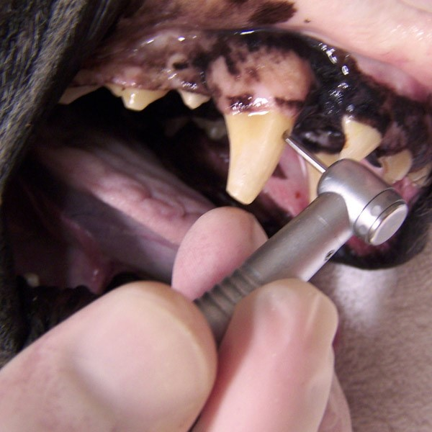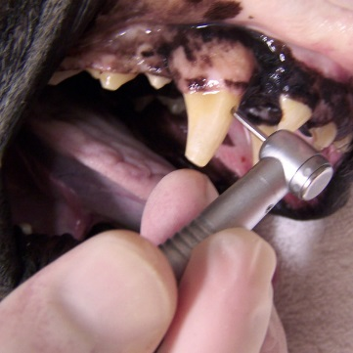

**What does the Veterinary**

**Dental Specialist do?**

Board certified veterinary dental specialists are trained to evaluate genetic as well as acquired problems. Advanced diagnostics, including dental radiology and laboratory evaluations, allow proper diagnosis of the oral health and related medical problems prior to treatment planning.

Since the veterinary dental specialist is trained in surgery, medicine and dentistry, a wide range of special treatment options can be implemented.

Patients with oral health problems usually require general anesthesia for evaluation and treatment. Veterinary dental specialists receive extensive training in the safe and effective use of anesthesia and pain management.

AVDC diplomates are prepared to implement appropriate therapeutic programs to improve oral health and the general wellness of their patients.

**What is the AVDC?**

The American Veterinary Dental College (AVDC) was established in 1988. The College is recognized by the American Veterinary Medical Association (AVMA) as the certifying organization for specialists in veterinary dentistry. The AVDC is committed to progress in veterinary dentistry by promoting continuing education programs for its members and veterinarians that are interested in developing and maintaining their techniques and skills in veterinary dentistry.

New knowledge, instrumentation and techniques continually develop, and Diplomates of the AVDC stay focused on these events and are often the leaders in development of state-of-the-art techniques in the veterinary dental field.

The AVDC believes that quality dental care for animals promotes increased longevity, decreases pain, and results in an improved quality of life for pets.

For further information visit the

AVDC web site at: www.AVDC.org

